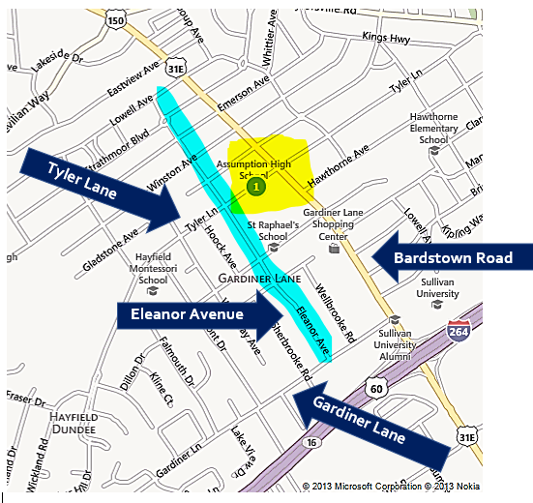
Neighborhood Streets around Assumption

