**ACCESS ID: 2025_____**

**ACCESS PASSWORD: 2025_____**

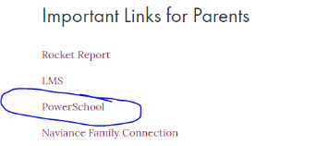

Go to our website **www.ahsrockets.org** , click **Parents** at top of page, then choose **Current Parents**. Under Important Links for Parents select **PowerSchool**

* Click on the PowerSchool link to access the Parent PowerSchool login page.
* Click Create Account with the Create Account button
* Fill in your information
* Please put your email address in the **Email** field and create a user name that you will remember in the **Desired User Name** field. *Please note that you cannot have an @ symbol in your username. While the program allows you to enter the @, it is an unrecognized character that will result in you being unable to log in.*
* Your password must be a minimum of 6 characters. The longer it is, the stronger it is.
* For student name, enter only your daughter’s last name.
* Your daughter’s Access ID is her **7 digit Student Number**
* The Access Password is that **same** **7 digit number**

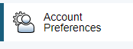

* **If you have more than one daughter at Assumption**, you may add a daughter to your account by clicking Account Preferences on the left, bottom of the page,
  + select the Student tab at the top of the page, then
  + click the blue Add button on the top right of the page. By adding all your daughters who are enrolled at Assumption for the 21-22 school year you will be able to access all of them with this one login.

Multiple parent/guardian accounts may be created for each student; allowing access for mother, father, step-parents, etc. Each account should be set-up with a unique email address, using the student ID number in the Access ID and Access Password fields.

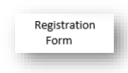**AND NOW TO REGISTER YOUR DAUGHTER**

Click ***Registration Form*** on the left side of the page and complete **ALL** requested information (especially important is ***contact information*** in the event of an emergency.) While we have filled some info based on previously provided data, please review, update, and correct including your daughter’s **LEGAL** name. We also request her preferred name (ex: Kate instead of Catherine) which is what we will list on classroom lists for teachers. Now, make sure and click “SUBMIT” at bottom of page



To pay your daughter’s registration fee go to the left side of the page and click ***MySchoolBucks.***

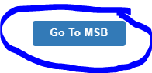

Click ***Get Started*** and in the upper right page, click ***Go To MSB***.

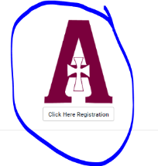

You will be directed to the MSB page and will scroll down until you see the Assumption “***A***” click to register to begin the payment process. You will create an MSB account to pay the $225 registration fee and complete the tuition selection form. Make sure to complete the full payment process.

**Please contact** [**brent.miller@ahsrockets.org**](mailto:brent.miller@ahsrockets.org) **if you have any problems or**

**you may contact the school office at 502-458-9551.**