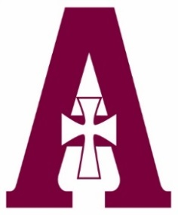
Assumption High School
School Uniforms
2019-2020

Shaheen’s is the exclusive provider of Assumption uniforms. Shaheen’s is a one-stop shop, offering shoes, socks, tights, belts, hair accessories, and a variety of additional accessories to complete your back-to-school shopping.
Visit www.shaheens.com for more information and easy shopping.

TOPS

White short sleeve polo
w/ AHS logo
Youth M-XL: $18.98
Adult: S-XL: $21.98

Dri-fit white short sleeve polo
w/ AHS logo
Junior XS-XL: 25.98
Junior 2XL: $27.98

White long sleeve polo w/ AHS logo
Youth M-XL: $21.98
Junior S-XL: $23.98

Black uniform sweater w/ AHS logo
Youth M-XL: $30.98
Adult S-XL: $35.98

Black quarter zip sweatshirt
w/ AHS logo
Adult XS-2XL: $29.98
BOTTOMS

Plaid GAT skirt
(Style: #D34-54)
Sizes 000-31: $32.98

Solid maroon GAT skirt
(Style: #D34)
Sizes 000-31: $29.98

Black pants w/ AHS logo
Pricing varies from $27.98-$33.98

SHAHEEN’S
(502) 899-1550
994 Breckenridge Lane
Louisville, KY 40207
Store hours:
Monday-Saturday 9:30 AM-6:00 PM; closed most Sundays

